 | Cognizant Academy  Pension Management System  FSE – Business Aligned Project  Case Study Specification  Version 1.0
 | Prepared By / Last Updated By | Reviewed By | Approved By
Name | Seshadri M R
Role | Solution Designer
Signature
Date

Table of Contents

1.0 Important Instructions 3
2.0 Introduction 4
2.1 Purpose of this document 4
2.2 Project Overview 4
2.3 Scope 4
2.4 Hardware and Software Requirement 5
2.5 System Architecture Diagram 6
3.0 System Requirements 6
3.1.1 Functional Requirements – Process Pension Microservice 6
3.1.2 Functional Requirements – Pensioner detail Microservice 8
3.1.3 Functional Requirements – Pension disbursement Microservice 9
3.1.4 Functional Requirements – Authorization Microservice 10
3.1.5 Functional Requirements – Pension Management portal 10
4.0 Cloud Deployment requirements 11
5.0 Design Considerations 11
6.0 Reference learning 11
7.0 Change Log 12

Important Instructions
- Associate must adhere to the Design Considerations specific to each Technolgy Track.
- Associate must not submit project with compile-time or build-time errors.
- Being a Full-Stack Developer Project, you must focus on ALL layers of the application development.
- Unit Testing is Mandatory, and we expect a code coverage of 100%. Use Unit testing and Mocking Frameworks wherever applicable.
- All the Microservices, Client Application, DB Scripts, have to be packaged together in a single ZIP file. Associate must submit the solution file in ZIP format only.
- If backend has to be set up manually, appropriate DB scripts have to be provided along with the solution ZIP file.
- A READ ME has to be provided with steps to execute the submitted solution, the Launch URLs of the Microservices in cloud must be specified.
(Importantly, the READ ME should contain the steps to execute DB scripts, the LAUNCH URL of the application)
- Follow coding best practices while implementing the solution. Use appropriate design patterns wherever applicable.
- You are supposed to use an In-memory database or code level data as specified, for the Microservices that should be deployed in cloud. No Physical database is suggested for Microservice.

Introduction

Purpose of this document
The purpose of the software requirement document is to systematically capture requirements for the project and the system “Pension Management System” that has to be developed. Both functional and non-functional requirements are captured in this document. It also serves as the input for the project scoping.
The scope of this document is limited to addressing the requirements from a user, quality, and non-functional perspective.
High Level Design considerations are also specificed wherever applicable, however the detailed design considerations have to be strictly adhered to during implementation.

Project Overview
State government aims to automate a portion of the Pension detail provisioning. This project covers pensioner detail provision, calculate provision, initiate pension disbursement.

Scope
Below are the modules that needs to be developed part of the Project:
Req. No. | Req. Name | Req. Description
REQ_01 | Process Pension module | This module is a Middleware Microservice that performs following operations:  - Determines if it’s a self or family pension. Calculate the pension amount post data authentication, and display on the web application user interface  - On confirmation from the admin to process the pension disbursement, Pension disbursement process should be initiated. List of error codes from Pension disbursement module should be maintained in this module. Based on the response appropriate message should be returned  - This module should receive input from the web application
REQ_02 | Pensioner detail module | This module is a Middleware Microservice that performs the following operations:  - Provides information about the registered pensioner detail i.e., Pensioner name, PAN, bank name, bank account number, bank type – private or public
REQ_03 | Pension disbursement module | This module is a Middleware Microservice that performs the following operations:  - Gets the pension amount along with pensioner aadhaar details. This internally gets the bank detail from the Pensioner detail Microservice. Checks if the bank service charge is credited along with the pension amount or not. If the data is correct, then success code is returned, else appropriate error code is returned  - This should be invoked from the ProcessPension microservice
REQ_04 | Authorization service | This microservice is used with anonymous access to Generate JWT
REQ_05 | Pension Management portal | A Web Portal that allows a member to Login and allows to do following operations:  - Login  - Load the pensioner detail  - Invoke the Process pension module  - Post validation of the pensioner detail, pension amount should be displayed on the UI. On approval, pension amount disbursal happens thru ProcessPension microservice  - Store the pensioner detail, pension amount and the bank transaction detail in database

Hardware and Software Requirement
- Hardware Requirement:
  - Developer Desktop PC with 8GB RAM
- Software Requirement (Dotnet)
  - Visual studio 2017 enterprise edition
  - SQL Server 2014
  - Postman Client in Chrome
  - Azure cloud access

System Architecture Diagram
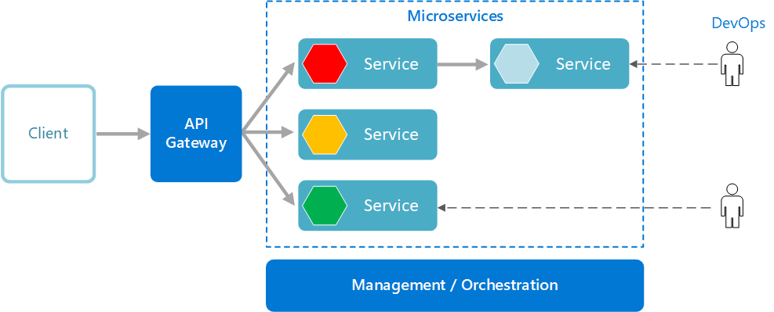

System Requirements

Functional Requirements – Process Pension Microservice
- Pension Management System | - ProcessPension Microservice
Functional Requirements
ProcessPension Microservice should be invoked from the web application. It allows the following operations:

- It takes in the pensioner detail like the name, aadhaar number, pan detail, self or family or both type of pension
- Verifies if the pensioner detail is accurate by getting the data from PensionerDetail Microservice or not. If not, validation message “Invalid pensioner detail provided, please provide valid detail.”. If valid, then pension calculation is done and the pension detail is returned to the Web application to be displayed on the UI

Entity

PensionerInput

- Name
<Pensioner name>
- Date of birth
<Pensioner date of birth>
- PAN
<Permanent account number>
- Aadhaar number
- Self or Family pension
<Option to be chosen>

PensionDetail

- Name
<Pensioner name>
- Date of birth
<Pensioner date of birth>
- PAN
<Permanent account number>
- Self or Family pension
<Is the pension earned for self or family pension>
- Pension amount
<Total pension amount>

ProcessPensionInput

- Aadhaar number
- Pension amount
<Total pension amount>

REST End Points
Claims Microservice
- GET: /PensionDetail (Input: pensionerInput | Output: pensionDetail)
- POST: /ProcessPension(Input: processPensionInput| Output: processingCode)

Trigger – Should be invoked from Pension management portal (local MVC app)
Steps and Actions
  - This microservice should have 2 REST endpoints
  - The GET endpoint should calculate the PensionInput, invoke the Pensioner detail microservice and get the salary detail. Pension amount calculation detail is as follows
    - Self pension: 80% of the last salary earned + allowances
    - Family pension: 50% of the last salary earned + allowances
  - The POST endpoint should invoke the PensionerDetail Pension disbursement microservice Along with the bank service charge. The microservice can have pre-defined list of banks and service charge as follows
    - Public banks – INR 500
    - Public banks – INR 550
  - The microservice should have pre-defined process codes and its message
    - 10 – Pension disbursement Success
    - 20 – Bank service charge not paid
    - 21 – Unknown error. Please try after sometime
  - On receiving the response from Pension disbursement microservice, if the process code is
    - 10 - the corresponding success message is returned to the web application.
    - 20 – the bank service charge should be added to the total amount and re-invoked
    - 21 – try the service HIT for 3 times. If the same code is returned, return the message to the web application

Non-Functional Requirement:
- Only Authorized requests can access these REST End Points

Functional Requirements – Pensioner detail Microservice
- Pension Management System | - PensionerDetail Microservice
Functional Requirements
The intent of this Microservice is to provide the Pensioner detail based on Aadhaar number. Post Authorization using JWT, pensioner detail like the name, PAN detail, Bank name and bank account number

Entities
PensionerDetail

- Name
<Pensioner name>
- Date of birth
<Pensioner date of birth>
- PAN
<Permanent account number>
- SalaryEarned
<Last earned salary by the pensioner>
- Allowances
<Sum of all the allowances>
- Self or Family pension
<Is the pension classification self or family pension>
- Bank detail
  - Bank name
  - Account number
  - Public or Private bank
<Bank detail>

REST End Points
PensionerDetail Microservice
  - GET: /PensionerDetailByAadhaar (Input: aadhaarNumber | Output: pensionerDetail)

Trigger – Should be invoked from ProcessPension microservice
Steps and Actions
- This Microservice is to fetch the pensioner detail by the Aadhaar number. This should be consumed by Process pension microservice.
- Flat file(CSV file with pre-defined data) should be created as part of the Microservice. This file has to contain data for 20 Pensioners. This has to be read and loaded into List for ALL the operations of the microservice.

Non-Functional Requirement:
- Only Authorized requests can access these REST End Points

Functional Requirements – Pension disbursement Microservice
- Pension Management System | - PensionDisbursement Microservice
Functional Requirements
PensionDisbursement Microservice should be invoked from the ProcessPension microservice. It allows the following operations:

- Receives input for Pension disbursement details from the ProcessPension microservice.
- This invokes the Pensioner detail Microservice to get the Bank details of the pensioner
- Based on the bank type, checks if the bank service charge is sent thru the corresponding field. This microservice should also the have pre-defined list of banks and service charge as follows, used for verification
    - Public banks – INR 500
    - Public banks – INR 550
- Check if all the relevant data is there in the input. If so, Success code should be returned, else the appropriate error message should be returned.
    - 10 - Success
    - 20 – the bank service charge should be added to the total amount
    - 21 – Unknown error

Entities

ProcessPensionInput

- Aadhaar number
- Pension amount
<Total pension amount>
- Bank service charge

ProcessPensionResponse

- ProcessPensionStatusCode
<Integer representing processing status>

REST End Points
PensionDisbursement Microservice
POST: /DisbursePension (Input: ProcessPensionInput | Output: ProcessPensionResponse)

Trigger: Should be invoked from ProcessPension microservice
Steps and Actions:
Non-Functional Requirement:
Only Authorized requests can access these REST End Points

Functional Requirements – Authorization Microservice
- Pension Management System | - Authorization Microservice
Security Requirements
- Create JWT
- Have the token expired after specific amount of time say 30 minutes
- Has anonymous access to get the token detail

Functional Requirements – Pension Management portal
- Pension Management System | - Pension Management Portal
Client Portal Requirements
- Pension Management Portal must allow a member to Login. Once successfully logged in, the member do the following operations:
  - Provide the pensioner detail
  - Invoke the ProcessPension microservice to get the pension detail
  - UI should receive validation message if the pensioner detail provided as input has invalid data
  - Display the processed pension detail on the UI
- The pensioner and pension detail should be saved to the database
- Each of the above operations should reach out to the middleware Microservices that are hosted in cloud.

Cloud Deployment requirements
- All the Microservices must be deployed in Cloud
- All the Microservices must be independently deployable. They have to use In-memory database or data in the application wherever applicable
- The Microservices has to be dockerized and these containers must be hosted in Cloud using CI/CD pipelines
- The containers have to be orchestrated using Azure Kubernetes Services.
- These services must be consumed from an MVC app running in a local environment.

Design Considerations
Java and Dotnet specific design considerations are attached here. These design specifications, technology features have to be strictly adhered to.

Reference learning
Please go through all of these k-point videos for

Microservices deployment into Azure Kubernetes Service.
AzureWithCICD-1
AzureWithCICD-2
AzureWithCICD-3
AzureWithCICD-4

Other References:

AppInsights logging | https://www.codeproject.com/Tips/1044948/Logging-with-ApplicationInsights
Error response in WebApi | https://stackoverflow.com/questions/10732644/best-practice-to-return-errors-in-asp-net-web-api
Read content from CSV | https://stackoverflow.com/questions/26790477/read-csv-to-list-of-objects

Change Log
 | - Changes Made
V1.0.0 | Initial baseline created on <25-Jul-2020> by <Seshadri M R>
 | Section No. | Changed By | Effective Date | Changes Effected

